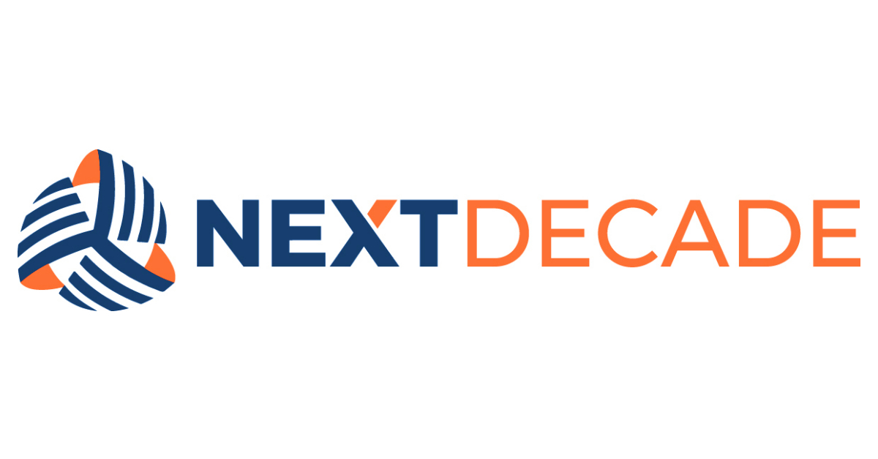

NAME
GUIDANCE DOCUMENT
xxx-xxx-xxx-xxx-xxx-#####

Table of Contents

1. PURPOSE 3
2. INTEGRATED GOVERNANCE FRAMEWORK 3
3. GUIDELINE 3
4. OWNERSHIP 3
5. APPROVAL 3
REVISION HISTORY 4

PURPOSE
The purpose of the [Name the Guidance] (“Guidance”) [Describe the Purpose].
This Guidance outlines ‘Best Practices Recommendations’ regarding [Name associated Procedure].
The Guideline applies to all employees, officers, directors, agents, consultants, contractors, and representatives, and any other individuals when they act on behalf of the Company (collectively “Workforce”).

INTEGRATED GOVERNANCE FRAMEWORK
This Guideline is part of NextDecade’s integrated Governance Framework. The Workforce should consider this Guideline when executing the step-by-step instructions outlined in the [Name associated Procedure].

GUIDELINE
[Content Description]
  - [Content Detail]
    - [Content Detail]
      - [Content Detail]

OWNERSHIP
Responsible | Accountable | Consulted | Informed

APPROVAL
Issuer / Title | Adopted By | Effective / Amended Date
s/ | NextDecade Corporation

REVISION HISTORY

Revision | Description of Changes and Notes
0 | Issued for Use

The Governance Framework outlines the rules, practices, and processes by which the Company is directed and controlled ensuring accountability, fairness, and transparency in the Company's relationship with its stakeholders, including shareholders, employees, customers, and the community.

